Alexander Cannell

Professor Robertson

CSIS 2600

Project 2-1



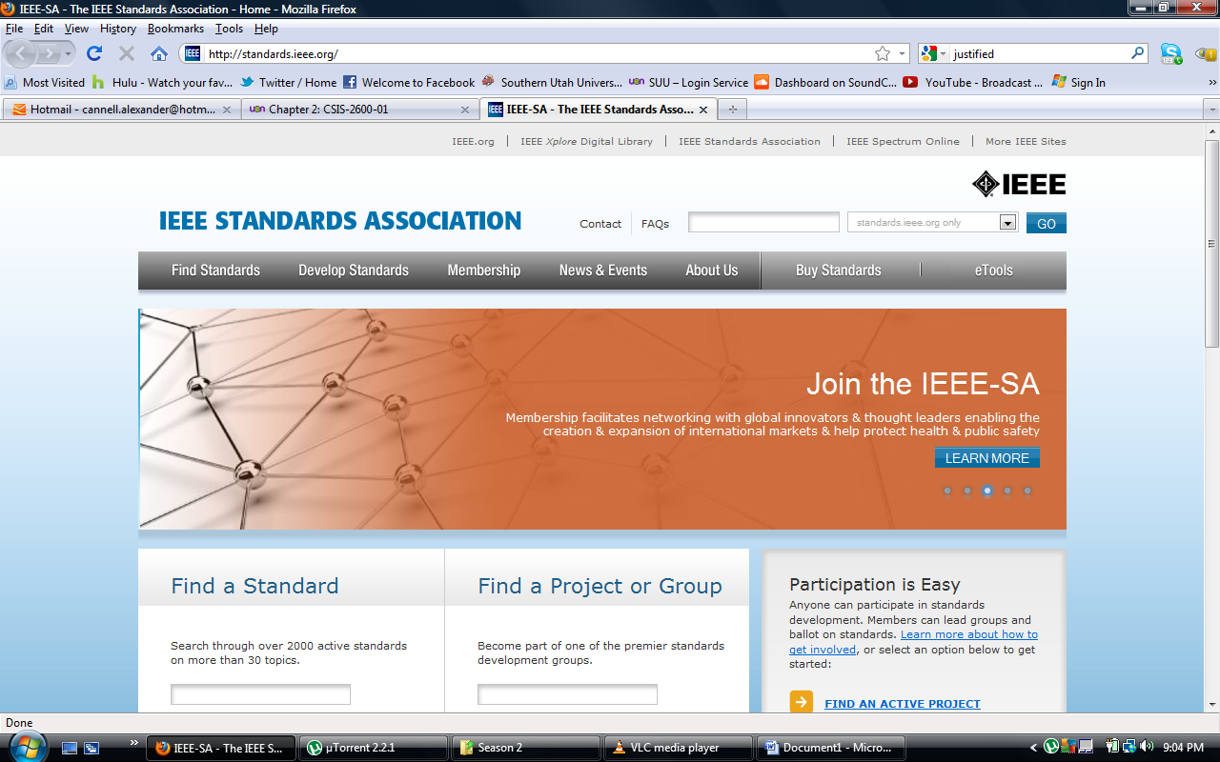

The <http://standards.ieee.org/> website.

3. <http://odysseus.ieee.org/query.html>

4. <http://standards.ieee.org/develop/project/802.3.html>

5. The P802.3 project standard draft.

6. 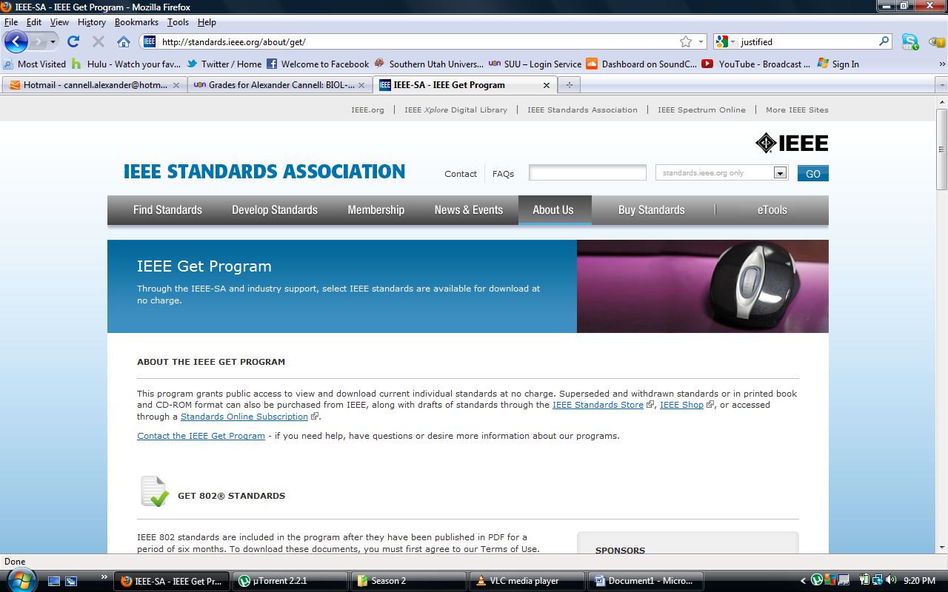

A list of standard ieee’s.

7. 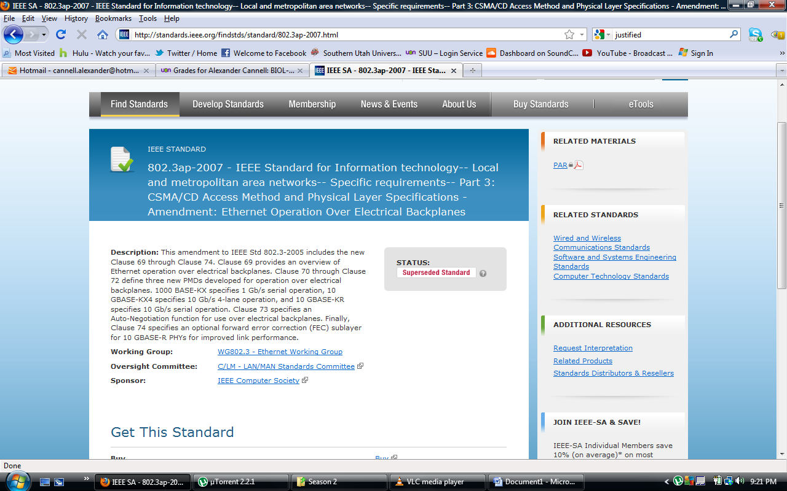

This shows what a csma/cd access method.

8. 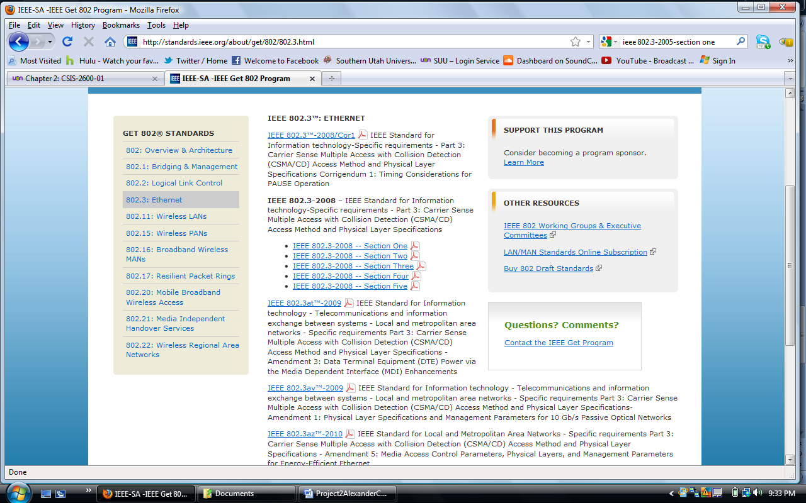

This shows the page where you download all five sections.

9. <http://standards.ieee.org/getieee802/download/802.3-2008_section1.pdf>

10.

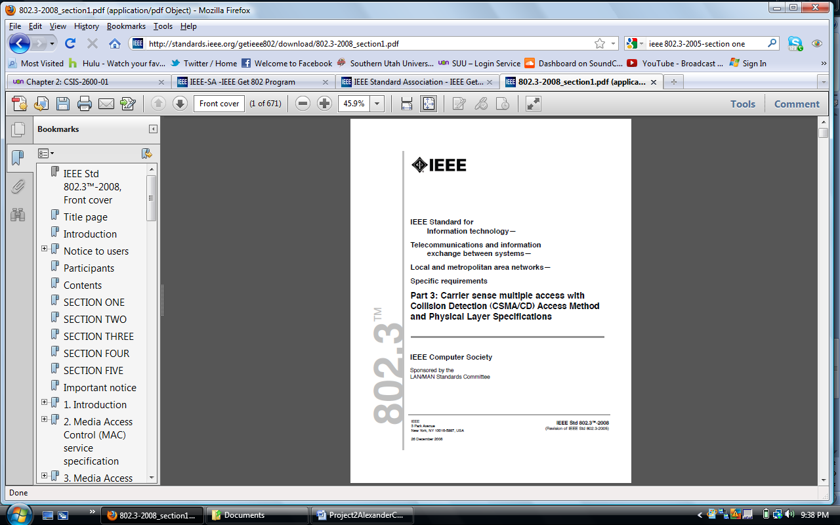

This shows I did download the(http://standards.ieee.org/getieee802/download/802.3-2008_section1.pdf) pdf file of section one.

13.

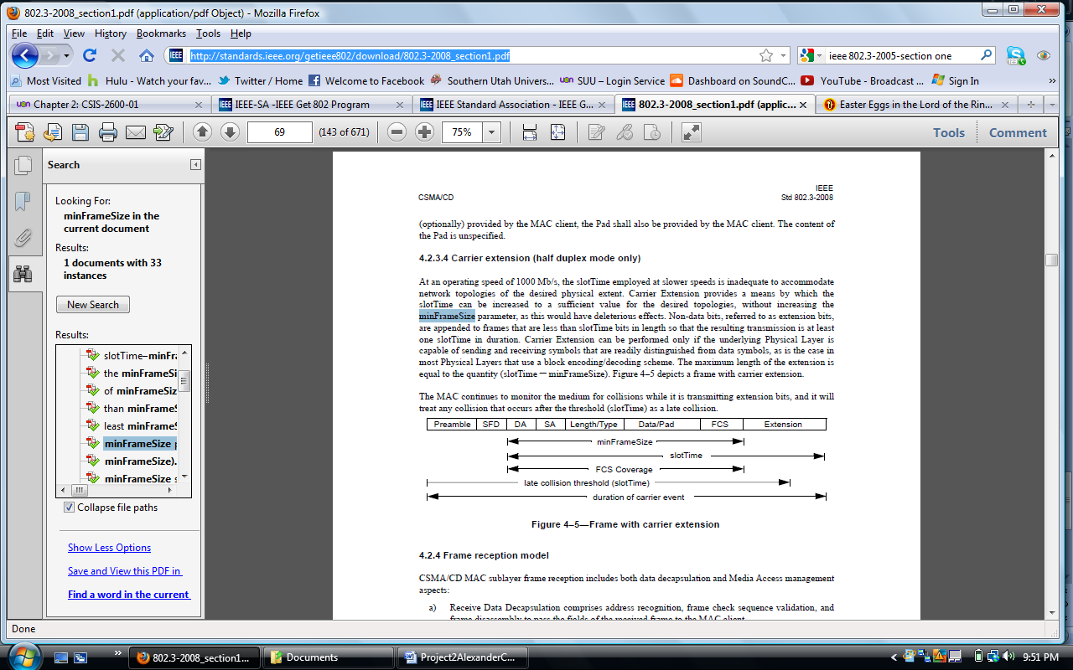

Shows the min length of the Ethernet frame.

Project 2-2

1. *Software*

Application(layer 7)- provides interface between software application and network for interpreting applications request and requirements.

Presentation(layer 6) – allows hosts and applications to use a common language; performs data formatting, encryption, and compression.

Session(layer 5) – establishes, maintains, and terminates user connections.

Transport(layer 4) – ensure accurate delivery data through flow control, segmentation and reassembly, error correction, and acknowledgment.

Network(layer 3) – establishes network connection; translates network addresses into their physical counterparts and determines routing.

Data link(layer 2)- packages data in frames appropriate to network transmission method.

Physical(layer 1) – manages signaling to and from physical network connections.

*Network*

1. Look above
2. The presentation layer sends its pdu to the session layer, which adds a session header that contains information about how your home computer communicates with the network. For example, the session header might indicate that your internet connection can only transmit and receives data at 512 kbps. The session layer then passes the pdu to the transport layer.
3. The maximum segments are 4.
4. 6. 7.

